Picture yourself in ancient Roman times cultivating the soil yourself with hand tools and maybe even a plow and horse. Now picture yourself today doing the same manual labor in the garden. Yuck! Why not purchase a garden tiller and let it do the heavy work for you!

Just what is a garden tiller? A garden tiller is a motorized rotary plow that ‘tills’ or cultivates the soil. Functioning independently (being operated by a human), or attached to a tractor (also operated by a human), the rotary blades continuously turn the soil providing easier access to nutrients and improving the soil structure for planting.

The garden tiller was in its initial stages of creation in 1912 by Arthur Clifford in Australia. By 1922, he found that it worked well and he established the Howard Rotavator Company, Ltd. The Rotovator is still in use today and is self propelled, moving forward and backwards. Dr. Konrad von Meyenburg also created a “machine for mechanical tilling” in 1910 and Troy-Bilt followed much later with the ‘Rototiller’ in the 1930’s. Nowadays there are literally hundreds of garden tillers available at your fingertips. Depending on the needs of your garden, how do you choose what will work? Here are a few simple hints to choosing a garden tiller.

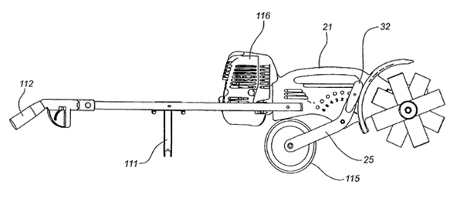
- Choose something easy to move and lightweight.
- Choose either electric or gas powered.
- Choose front or rear tined; front maintains already cultivated soil whereas rear is the workhorse of the garden for uncultivated soil.
- Check the horsepower: increased HP for breaking up new ground and decreased HP for the casual garden.
- Check the prices! There are lots of brand names and prices available. Consider what works best for you at the price you can afford.

Get to the garden and cultivate!

