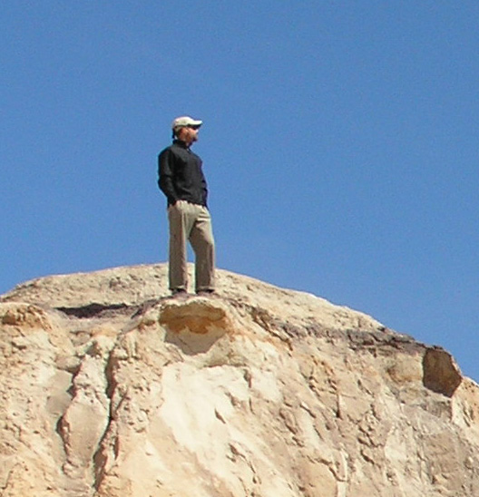

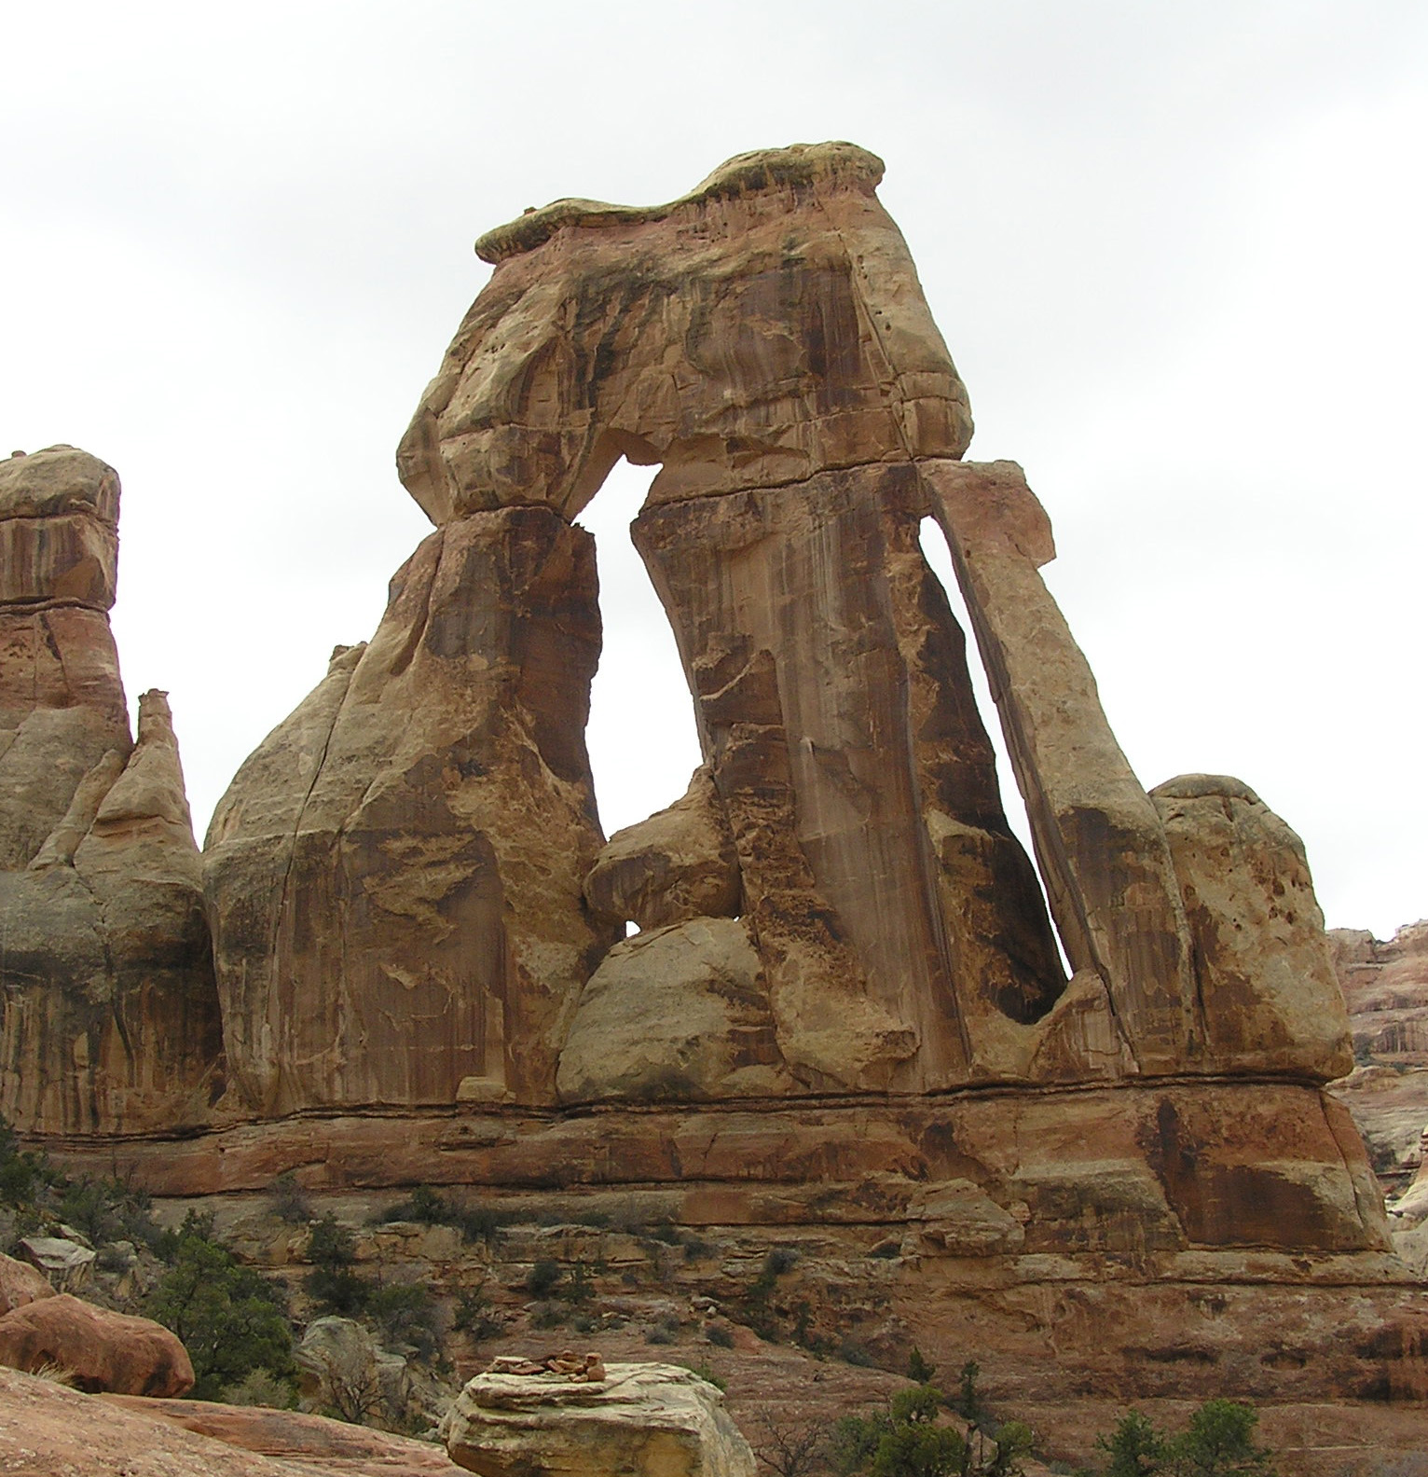

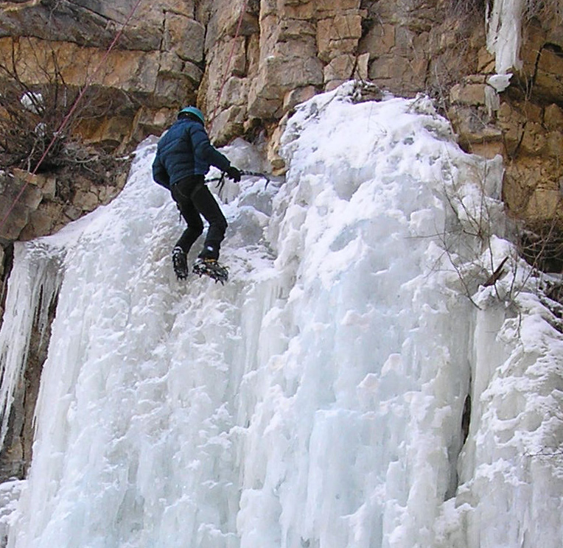

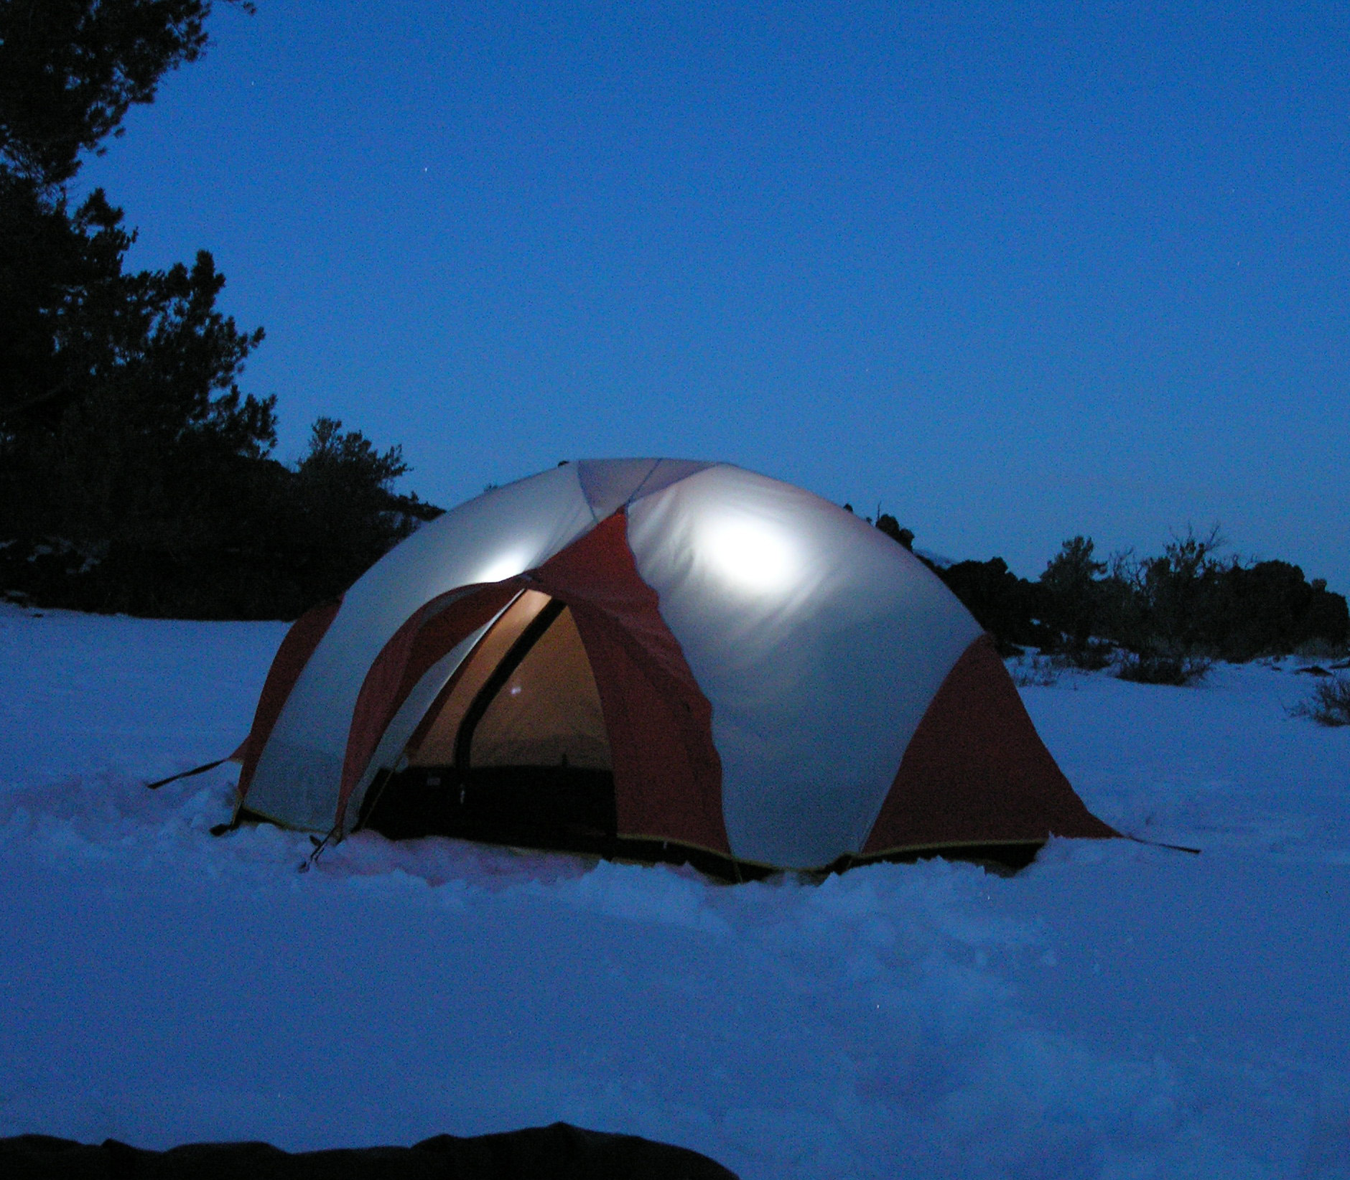

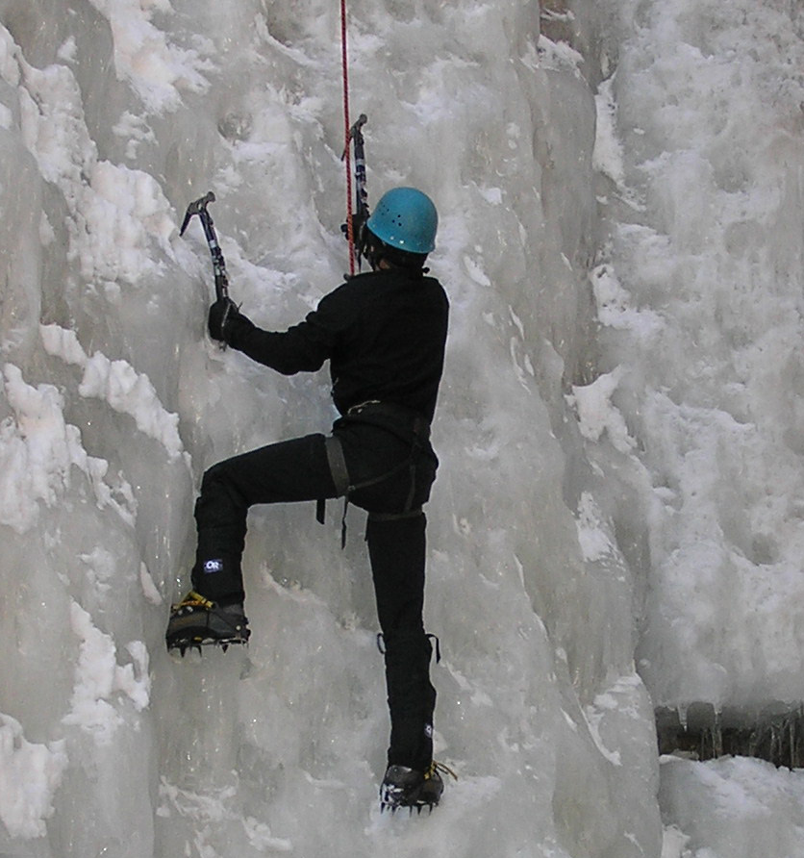

Climber7890
#H20ProTechT jacket leaked. OnUpOutfitters not helpful. Way overpriced for performance.

1 hour ago

HighAlt4567
Onward & Upward staff don’t know what they’re talking about. I’m taking my business elsewhere.

3 hours ago

Mtn_Ace
Waterproof maybe, but #H20ProTechT breathable NOT. More of an urban raincoat around town, not for hiking. No point wearing if above 70 degrees.

20 hours ago

PeakClimber987
#H20ProTechT Xcellent outer shell for gen outdoor hiking, biking. Some climbers think it fragile but durable for most uses.
20 May

Summit5678
Wore Onward & Upward #H20ProTechT jacket on mildly wet morning and was immediately cold and soaked: colder than had I not had on the jacket.
5 May

