**To:** [your name]

**Subject:** Bicycle Helmet Proposal Notes

Thanks for agreeing to develop this proposal. With more than 1.7 million people every year in the United States suffering a traumatic brain injury (TBI), I think the best way we can help families address this serious public health issue is through education and prevention. To help you get started, I’ve included below some notes on the idea as well as some graphics you might choose to include in the proposal. I’m not sure if we should include visuals or if the ones I found are suitable. What do you think?

Thanks,

Rene

Although there is no federal law in the U.S. requiring bicycle helmets, King County adopted in 1997 a bicycle helmet law requiring youths 16 and under to wear an approved protective helmet. In fact, 14 states still have no state or local bicycle helmet laws.

In 2011, police officers in King County issued 205 tickets or warnings for helmet law violations. A common reason given by children for not wearing a helmet was that they did not own a helmet. Many also said they could not afford one.

We need to provide helmets to families who cannot afford them. If families cannot afford helmets, then they certainly cannot afford the medical bills if kids sustain head injuries.

We could also give out “citations” to kids who are wearing helmets, encouraging positive behavior. I’ve attached an example from the Norwood Police Department.

In 2011, 19 children under the age of 16 were hospitalized from bicycle-related traumatic brain injuries in King County. In fact, according to the Maine Bureau of Highway Safety, “More children, ages 5 to 14, go to hospital emergency rooms for injuries associated with bicycles than with any other sport.”

We should give each police officer brochures to give to minors who are not using helmets. These brochures should emphasize the risks they are taking and encourage them to wear helmets. We could also educate kids on the proper way to wear a helmet (see my second and third attachments). Correctly worn, a bicycle helmet can reduce the chance of head injury by up to 85 percent.

Police to issue coupons redeemable at fire or police stations for free helmets. Another option is to place a few helmets in each police vehicle so officers can hand them out right on the spot.

Approximately 8,500 children between the ages of 5 and 16 are living in King County in today. Many already have helmets or can easily afford one, so we probably need funds for about 100 helmets. Need small, medium, and large helmets. Helmets need to be unisex in color and design.

If we can just get 100 children who otherwise would not wear a helmet to do so, we can make a difference. As more kids wear helmets, they’ll see it’s cool to wear a helmet.

Attachment 1: Norwood Police Citation Attachment 2: Bicycle Helmet Fit

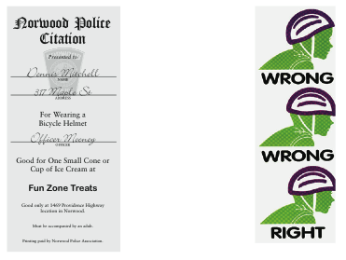

Attachment 3: Bicycle Helmet Fit

