Statistics on Bandwidth Use from the Campus IT Office

 | P2P | Browser | Email | Streaming
12:00 AM | 40 | 25 | 5 | 30
2:00 AM | 55 | 15 | 5 | 25
4:00 AM | 60 | 10 | 5 | 25
6:00 AM | 60 | 10 | 0 | 30
8:00 AM | 40 | 15 | 0 | 45
10:00 AM | 20 | 30 | 5 | 45
12:00 PM | 20 | 40 | 10 | 30
2:00 PM | 25 | 30 | 5 | 40
4:00 PM | 30 | 30 | 5 | 35
6:00 PM | 40 | 30 | 10 | 20
8:00 PM | 40 | 25 | 10 | 25
10:00 PM | 45 | 25 | 5 | 25

Numbers on the table represent the percentage of network resources that were devoted to different categories of applications during a typical 24-hour period

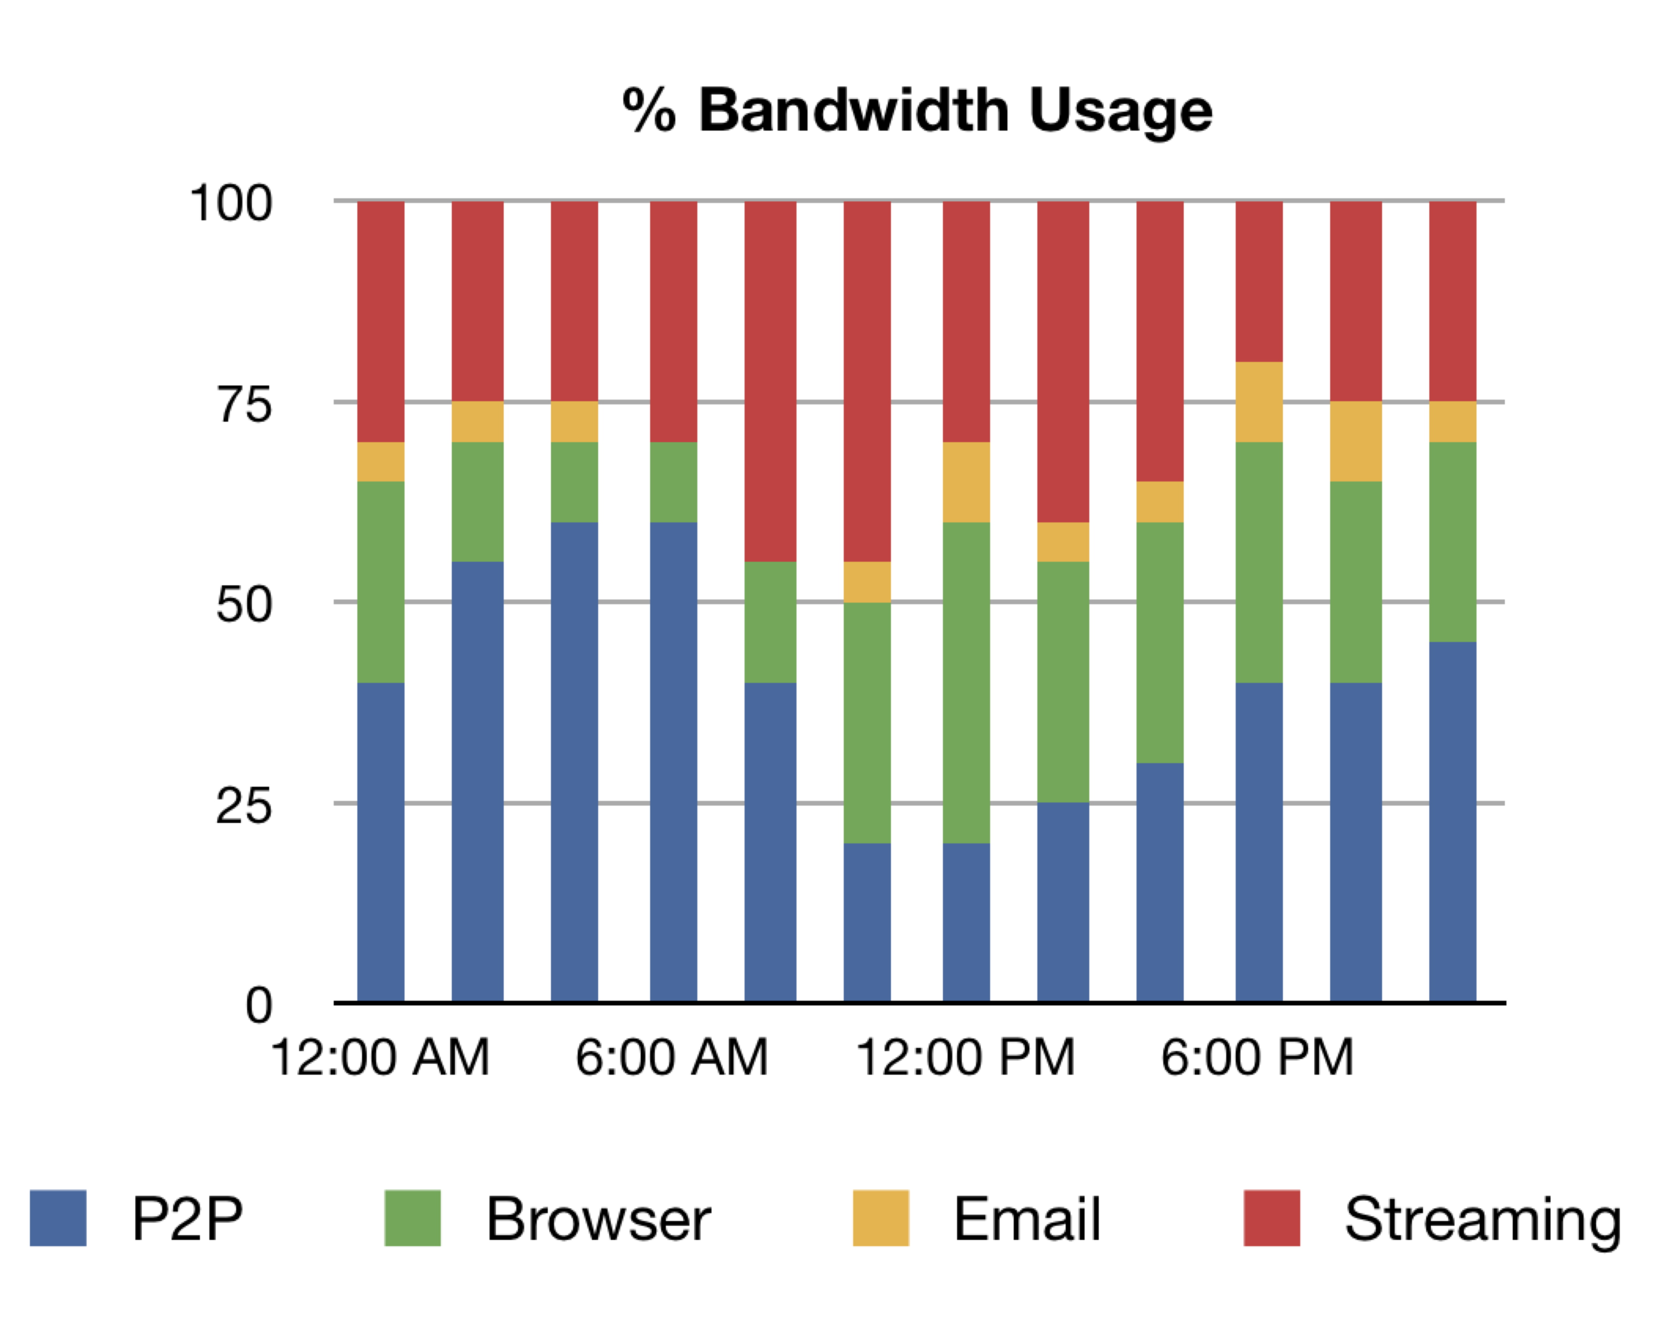

Information from the table has been converted to a graph

