Use Your Knowledge Activity – Biogeography - Chapter 17: Life on Earth
Task:

Use your knowledge of evolution, biogeography, and plate tectonics to determine the evolutionary patterns of the hypothetical species in this example.

The diagram below represents the current locations of four hypothetical landforms: Eastern Rectanglia, Western Rectanglia, Northern Squaringia, and Southern Squaringia. The four current landforms were originally one large landform that broke apart over time. The landforms are currently too far apart for species to move from one to the other. The shapes represent different species living on each landform, and all these species share a common ancestor. All of the species are still living except for Squarita whitus (), which is the only fossil.

Team up with another student to interpret the biogeography of these species to answer the questions.
Part 1: Biogeography: Use the diagram to answer questions about the evolutionary and geologic history.

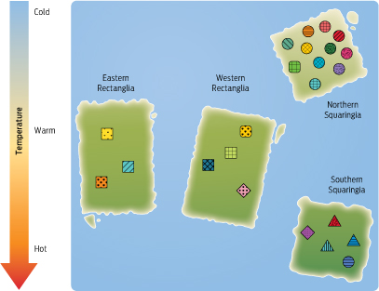
Questions:
- Based on the locations of each type of species, draw arrows between the landforms in the diagram above to indicate how the original landform moved and split apart.

- Sketch the shapes of the species which have the most species that are adapted to the following temperatures:
Cold temperatures Warm temperatures Hot temperatures

- What is the most likely reason that a circular-shaped species is found in Southern Squaringia?

- Which landform is the site of a major adaptive radiation?
Part 2: Tree construction and interpretation: Use the patterns of biogeography and the structure of the tree below to sketch the shape of the common ancestors and identify the regions where the species are found.

Identify the regions where species are found.
Sketch the shape of the common ancestors:

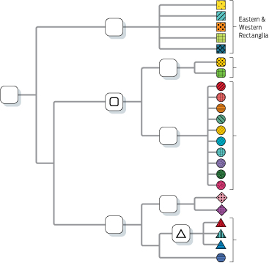
Instructor notes: This activity could be done with students prior to lecturing about biogeography and/or tree structure, but will probably work best if given after the students receive this introductory material in lecture. Students should work in teams of two to solve the questions. The background information given on page 1 is important to the activity⎯this information can either be presented in a short introduction to the activity (recommended), or students can read it themselves. This activity can be broken up into separate parts if desired (Parts 1 and 2 can be done either together or alone).
Total time budget = 12–17 min
- 2 min introduction to activity
- 5 min for group work on Part 1
- 5 min for group work on Part 2
- 3–5 min optional class discussion following activity

RUBRIC: 19 points total
  - Part 1: 10 points total
    - Question 1: 1 point for each correctly drawn arrow (3) depicting landmass movement
    - Question 2: 1 point for each correct answer in dashed boxes
    - Questions 3 and 4: 2 points each for correct answers

  - Part 2: 9 points total (10 points if done without Part 1)

    - 1 point per correct answer in each dashed box
    - If done without Part 1, additional 1 point for correctly drawing three arrows depicting landmass movement on diagram

KEY: PART 1
Part 1: Biogeography: Use the diagram to answer questions about the evolutionary and geologic history.

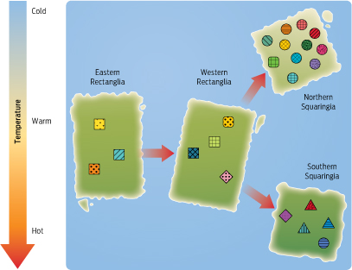
Questions:
- Based on the locations of each type of species, draw arrows between the landforms in the diagram above to indicate how the original landform moved and split apart.

- Sketch the shapes of the species which have the most species that are adapted to the following temperatures:
Cold temperatures Warm temperatures Hot temperatures

- What is the most likely reason that a circular-shaped species is found in Southern Squaringia?
Convergent evolution (It is the result of convergent evolution; although looks like the circles on Northern Squaringia; it is most closely related to the triangles.)

- Which landform is the site of a major adaptive radiation?
Northern Squaringia (The circle-shaped species underwent an adaptive radiation there, with the evolution of many new species.)

KEY Part 2: Tree construction and interpretation: Use the patterns of biogeography and the structure of the tree below to sketch the shape of the common ancestors and identify the regions where the species are found.

Identify the regions where species are found.
Sketch the shape of the common ancestors.

