Use Your Knowledge Activity - Radiometric Dating - Chapter 17: Life on Earth
Task:

Use your knowledge of geologic layers, relative dating, and radiometric dating to determine the age of this hypothetical fossil.

You are a paleontologist excavating fossils found in layers of sedimentary rock. Between some of the layers are layers of igneous rock, each formed when a nearby volcano erupted and covered the landscape with a thick layer of lava. You find a fossil of a fish and want to determine how old it is. You use radiometric dating to determine the ages of different rock samples (mya = million years ago).
Team up with another student to critically evaluate the radiometric dating data.
Answer the following questions based on your evaluation of the data and knowledge of radiometric dating.

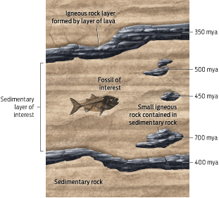
3) Would you use carbon-14 to date this fossil? Why or why not? Explain.
1)

2)

4) What are two reasons you would not use carbon-14 to date the smaller igneous rocks in the rock around the fossil?
1) Based on the radiometric dates of the igneous rocks, estimate the age of the fossil.

2) Explain how older igneous rocks could end up in newer sedimentary rock layers.

Instructor notes: Each student should get a copy of the worksheet. Students should form groups of two to work together to solve the questions.
Total time budget = 6–10 min
- 1 min introduction to activity
- 5 min group work
- 2–4 min optional follow-up class discussion of answers

RUBRIC: 5 points total (1 point for Questions 1–3; 2 points for Question 4―1 for each reason)

KEY:

No, carbon-14 would not make sense to date this fossil because of the age of the fossil. Carbon-14 has a very short half-life (5,730 years) and so carbon-14 is not useful to date organic remains more than 50,000 years old (because it would have all decayed by this point). This fossil is much older (350–400 million years old) so dating with carbon-14 would not be useful.
3) Would you use carbon-14 to date this fossil? Why or why not? Explain.
Existing igneous rocks could be eroded and washed away in rivers. They can be buried in layers of sediment. If this sediment turns into rock, the igneous rocks would be contained in this newer sedimentary rock.
The fossil is between 400 and 350
million years old. Although some of the rocks in the layer are older, the fossil is bracketed by two layers of lava, so the sedimentary rock in between was most likely deposited in the time between these volcanic eruptions.
1) Carbon-14 is only useful for dating organic materials; igneous rocks are made of inorganic materials.

2) Even if organic materials were present, the rocks are too old to be dated with carbon-14.

4) What are two reasons you would not use carbon-14 to date the smaller igneous rocks in the rock around the fossil?
1) Based on the radiometric dates of the igneous rocks, estimate the age of the fossil.

2) Explain how older igneous rocks could end up in newer sedimentary rock layers.

