Use Your Knowledge Activity - Oil-Eating Bacteria - Chapter 18: Prokaryotic diversity

Task:

Your environmental task force is responsible for cleaning up a massive oil spill that occurred in the Pacific Ocean off the coast of southern California, near San Diego and Los Angeles. Use your knowledge of bacteria to determine how oil-eating bacteria will function under different conditions.

Some bacteria species can digest hydrocarbons found in fossil fuels, such as crude oil. The actions of these bacteria aid in oil spill cleanup efforts, but the amount of bacteria activity is influenced by environmental conditions. You are studying a species of bacteria that thrives and grows best in warm water that has a high oxygen concentration.
Team up with one other student to predict the effect of oil-eating bacteria on four different oil spill scenarios (Spills A–D show each spill’s location) and answer the questions below.

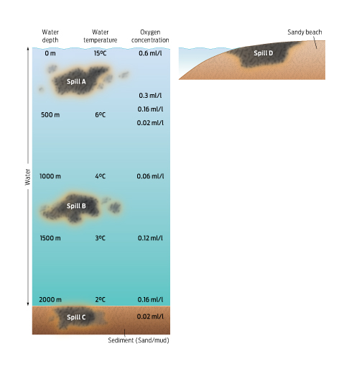

1) Determine the environmental characteristics at each spill site to fill out the table below. Use comparative terms like “shallow,” “warm,” “cold,” “high,” “low,” etc.
Spill | Depth | Temperature | Oxygen
A
B
C
D
2) Most of the oil-eating bacteria thrive best in areas with high oxygen concentrations.

- Which area would these bacteria digest the oil most quickly?
- Which area would these bacteria digest the oil most slowly?
- Why might bacteria have a hard time digesting oil in Spill C?

- What environmental conditions are unique to Spill D that the bacteria would need to be able to tolerate to digest the oil?

5) Bacteria use up oxygen in the water as they digest oil. What action could you take if bacteria around Spill A depleted the oxygen levels?

Instructor notes: This activity addresses Driving Questions #2 (what are the features of bacteria) and #3 (what are the challenges faced). Rather than looking at a bacteria’s tolerance for extreme conditions, this activity considers the conditions under which the bacteria would thrive.
Students should work in pairs to answer the questions about bacteria activity.
An extra discussion question could focus post-activity class discussion on the potential consequences of manipulating the environmental conditions to promote bacterial activity (there could be unforeseen consequences of affecting a complex marine ecosystem).
Total time budget = 6–10 min
- 1 min activity introduction and choosing pairs
- 5 min students work together in pairs to solve the questions
- 2–4 min optional class discussion of answers or additional discussion (see above)

RUBRIC: 8 points total
- Question 1: 2 points filling out the table completely
- Question 2: 2 points total―1 point for each part
- Question 3: 1 point
- Question 4: 1 point
- Question 5: 2 points
KEY:

Spill A (warm water, lots of oxygen)
Spill C (coldest and lowest oxygen) and maybe Spill D (much drier than other sites)
Spill D is on land, so the major difference is that it is much drier. The bacteria would need to be able to tolerate these drier conditions in order to digest the oil here.
These bacteria like warm and oxygen-rich habitats. In a cold oxygen-poor habitat, they would probably grow very slowly and not digest much oil. Also, bacteria may have a harder time accessing oil stuck in sediments.
- Determine the environmental characteristics at each spill site to fill out the table below. Use comparative terms like “shallow,” “warm,” “cold,” “high,” “low,” etc.
Spill | Depth | Temperature | Oxygen
A | shallow | warm | high
B | moderate | cool | moderate
C | deep | cold | low
D | surface | warm | high
- Most of the oil-eating bacteria thrive best in areas with high oxygen concentrations.

- Which area would these bacteria digest the oil most quickly?
- Which area would these bacteria digest the oil most slowly?
- Why might bacteria have a hard time digesting oil in Spill C?

- What environmental conditions are unique to Spill D that the bacteria would need to be able to tolerate to digest the oil?
Clean-up crews sometimes add fertilizer to shallow oil spills that are becoming oxygen-poor. The fertilizer promotes the growth of photosynthesizing organisms, which produce oxygen that can make the water more oxygen-rich.
- Bacteria use up oxygen in the water as they digest oil. What action could you take if bacteria around Spill A depleted the oxygen levels?

