Biology for a Changing World 2e, Chapter 26 Test Bank

1. Which of the following is NOT part of the digestive system?
- stomach
- liver
- pancreas
- kidneys
- All of the above are part of the digestive system.
Answer: D
DQ: What is the anatomy of the digestive system?
Type: Know It
Difficulty: Easy
Important Words/Concepts: digestive system/tract

2. Define digestion.

Answer: the mechanical and chemical breakdown of food into molecules that can be absorbed

DQ: How is food broken down and utilized as it moves through the digestive tract?
Type: Know It
Difficulty: Medium
Important Words/Concepts: digestion, amylase, pepsin, lipase, small intestine, villi

3. What is the sequence through which food passes in the digestive tract?

Answer: mouth, esophagus, stomach, small intestine, large intestine, rectum, anus

DQ: What is the anatomy of the digestive system?
Type: Know It
Difficulty: Medium
Important Words/Concepts: digestive tract

4. Describe the journey of food from the mouth to the stomach.

Answer: In the mouth, food is mechanically digested by the crushing and ripping action of the teeth. It is also chemically digested by enzymes secreted by the salivary glands. Then the food is pushed into the esophagus by the tongue and pushed into the stomach by waves of muscular contractions.

DQ: What is the anatomy of the digestive system?
Type: Know It
Difficulty: Medium
Important Words/Concepts: mouth, ingestion, peristalsis, esophagus, digestive tract

Correctly identify each of the digestive system organs that are numbered on the diagram below. (Questions 5–15)

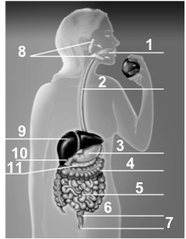4

5. The organ labeled 1 is the __________.
A. mouth
  - esophagus
  - stomach
  - large intestine
  - small intestine
Answer: A
DQ: What is the anatomy of the digestive system?
Type: Know It
Difficulty: Easy
Important Words/Concepts: digestive tract/system, ingestion, salivary glands

6. The organ labeled 2 is the __________.
- anus
- rectum
- large intestine
- stomach
- esophagus
Answer: E
DQ: What is the anatomy of the digestive system?
Type: Know It
Difficulty: Easy
Important Words/Concepts: upper digestive tract

7. The organ labeled 3 is the __________.
  - esophagus
  - stomach
  - liver
  - pancreas
  - small intestine
Answer: B
DQ: What is the anatomy of the digestive system?
Type: Know It
Difficulty: Easy
Important Words/Concepts: upper digestive tract

8. The organ labeled 4 is the __________.
  - pancreas
  - stomach
  - large intestine
  - small intestine
  - rectum
Answer: C
DQ: What is the anatomy of the digestive system?
Type: Know It
Difficulty: Easy
Important Words/Concepts: small vs. large intestine, absorption

9. The organ(s) labeled 5 is (are) the __________.
  - large intestine
  - small intestine
  - esophagus
  - gallbladder
  - salivary glands
Answer: B
DQ: What is the anatomy of the digestive system?
Type: Know It
Difficulty: Easy
Important Words/Concepts: small vs. large intestine, chemical digestion, duodenum

10. The organ labeled 6 is the __________.
  - anus
  - gallbladder
  - small intestine
  - rectum
  - liver
Answer: D
DQ: What is the anatomy of the digestive system?
Type: Know It
Difficulty: Easy
Important Words/Concepts: large intestine, elimination, stool, rectum

11. The organ labeled 7 is the __________.
  - rectum
  - anus
  - small intestine
  - pancreas
  - liver
Answer: B
DQ: What is the anatomy of the digestive system?
Type: Know It
Difficulty: Easy
Important Words/Concepts: digestive tract, anus, large intestine, elimination

12. The organ(s) labeled 8 is (are) the __________.
  - pancreas
  - mouth
  - liver
  - salivary glands
  - gallbladder
Answer: D
DQ: What is the anatomy of the digestive system?
Type: Know It
Difficulty: Medium
Important Words/Concepts: mouth, digestion/ingestion, amylase, salivary glands

13. The organ(s) labeled 9 is (are) the __________.
  - salivary glands
  - esophagus
  - gallbladder
  - liver
  - pancreas
Answer: D
DQ: What is the anatomy of the digestive system?
Type: Know It
Difficulty: Easy
Important Words/Concepts: digestive system, bile salts

14. The organ(s) labeled 10 is (are) the __________.
  - salivary glands
  - esophagus
  - gallbladder
  - pancreas
  - small intestine
Answer: C
DQ: What is the anatomy of the digestive system?
Type: Know It
Difficulty: Easy
Important Words/Concepts: bile salts, emulsify

15. The organ(s) labeled 11 is (are) the __________.
  - small intestine
  - large intestine
  - liver
  - salivary glands
  - pancreas
Answer: E
DQ: What is the anatomy of the digestive system?
Type: Know It
Difficulty: Easy
Important Words/Concepts: lipase, chemical digestion, pancreatic juice

16. Food passes through which of the following digestive organs?
- stomach
- liver
- pancreas
- A and B
- A, B, and C
Answer: A
DQ: What is the anatomy of the digestive system?
Type: Know It
Difficulty: Medium
Important Words/Concepts: chyme, stomach acid, pepsin, peristalsis

17. As food travels through the digestive system, __________.
- macromolecules are broken down into subunits
- nutrients are absorbed
- nutrients are delivered to body tissues
- waste is eliminated
- A, B, and D
Answer: E
DQ: How is food broken down and utilized as it moves through the digestive tract?
Type: Know It
Difficulty: Hard
Important Words/Concepts: chemical digestion, villi, enzymes, elimination

18. In the mouth, __________ digestion occurs.
- mechanical
- carbohydrate
- protein
- mechanical and carbohydrate
- mechanical and fat
Answer: D
DQ: How is food broken down and utilized as it moves through the digestive tract?
Type: Know It
Difficulty: Medium
Important Words/Concepts: chemical vs. mechanical digestion, amylase, chewing

19. The correct order of events in obtaining nutrients from food is __________.
- digestion, ingestion, elimination
- elimination, ingestion, digestion
- ingestion, elimination, digestion
- ingestion, digestion, elimination
- digestion, elimination, ingestion
Answer: D
DQ: How is food broken down and utilized as it moves through the digestive tract?
Type: Know It
Difficulty: Medium
Important Words/Concepts: ingestion vs. digestion, elimination

20. Compare and contrast plant nutrition to our nutrition, noting where food comes from, how it is used and stored, and where nutrients come from.

Answer: Answers will vary, but should include the ability of plants to make their own food from sunlight versus the need for humans to ingest their own food. In both, however, the nutrition is used for growth and reproduction. In animals, excess energy is stored as either fat or glycogen, while plants store their extra energy as starch or oils. The following is a more complete answer than can be made from the information in the text: Plants make carbohydrates through photosynthesis and metabolize them through respiration similar to the way that humans do. Plants can also convert carbohydrates to proteins if they have enough available nitrogen. Nitrogen and most other element nutrients are brought into the plant through soil water absorbed into the roots.

DQ: How is food broken down and utilized as it moves through the digestive tract?
Type: Use It
Difficulty: Hard
Important Words/Concepts: digestion, photosynthesis

21. The stomach is part of the ______ digestive tract.
A. secondary
B. upper
C. chemical
D. remedial
E. mechanical
Answer: B
DQ: What is the anatomy of the digestive system?
Type: Know It
Difficulty: Easy
Important Words/Concepts: mouth, esophagus, stomach

22. One main role of the stomach is to chemically digest __________.
A. complex carbohydrates
B. phospholipids
C. simple carbohydrates
D. water
E. proteins
Answer: E
DQ: How is food broken down and utilized as it moves through the digestive tract?
Type: Know It
Difficulty: Medium
Important Words/Concepts: stomach acid, chyme, pepsin

23. The liquid mixture of food, water, acid, and enzymes in the stomach is called __________.
A. chimera
B. peristalsis
C. pepsin
D. chyme
E. pepsinogen
Answer: D
DQ: How is food broken down and utilized as it moves through the digestive tract?
Type: Know It
Difficulty: Easy
Important Words/Concepts: stomach acid, duodenum, chemical digestion

24. The ________ connect(s) the mouth to the stomach.
A. esophagus
B. peritoneum
C. ligaments
D. bolus
E. pancreas
Answer: A
DQ: What is the anatomy of the digestive system?
Type: Know It
Difficulty: Easy
Important Words/Concepts: digestive tract

25. Salivary amylase digests __________.
A. proteins
B. polypeptides
C. carbohydrates
D. vitamins
E. minerals
Answer: C
DQ: How is food broken down and utilized as it moves through the digestive tract?
Type: Know It
Difficulty: Medium
Important Words/Concepts: chemical digestion, salivary glands

26. The role of teeth is ______ digestion.

Answer: mechanical

DQ: How is food broken down and utilized as it moves through the digestive tract?
Type: Know It
Difficulty: Easy
Important Words/Concepts: chemical vs. mechanical digestion

27. What is peristalsis?

Answer: waves of muscular contractions that push food through the digestive tract

DQ: How is food broken down and utilized as it moves through the digestive tract?
Type: Know It
Difficulty: Medium
Important Words/Concepts: muscle contractions, chyme

28. What is pepsin?

Answer: a protein-digesting enzyme that is active in the stomach

DQ: How is food broken down and utilized as it moves through the digestive tract?
Type: Know It
Difficulty: Medium
Important Words/Concepts: enzymes, digestion, stomach

29. The stomach is composed of muscle tissue, and muscle tissue is primarily protein. Why doesn’t the stomach digest itself?

Answer: The stomach is coated in a layer of mucus that protects it from acid and digestive enzymes.

DQ: How is food broken down and utilized as it moves through the digestive tract?
Type: Use It
Difficulty: Medium
Important Words/Concepts: stomach ulcers, mucus, stomach acid

30. The organs of the upper digestive tract include the __________.
  - mouth
  - esophagus
  - stomach
  - small intestine
E. A, B, and C
Answer: E
DQ: What is the anatomy of the digestive system?
Type: Know It
Difficulty: Easy
Important Words/Concepts: upper digestive tract

31. In the upper digestive tract, mechanical breakdown occurs in the __________.
- mouth
- esophagus
- stomach
- A and B
- B and C
Answer: A
DQ: How is food broken down and utilized as it moves through the digestive tract?
Type: Know It
Difficulty: Medium
Important Words/Concepts: mechanical vs. chemical digestion, chewing

32. In the upper digestive tract, enzymes are produced by the __________.
- tongue
- salivary glands
- esophagus
- stomach
E. B and D
Answer: E
DQ: How is food broken down and utilized as it moves through the digestive tract?
Type: Know It
Difficulty: Medium
Important Words/Concepts: amylase, pepsin, upper digestive tract

33. In the esophagus, peristalsis __________.
- mechanically breaks down food
- moves food from the mouth to the stomach
- secretes pepsin to help break down protein
- mixes food with acid and pepsin
- C and D
Answer: B
DQ: How is food broken down and utilized as it moves through the digestive tract?
Type: Know It
Difficulty: Medium
Important Words/Concepts: muscle contractions, digestive tract

34. In the stomach, peristalsis __________.
- mechanically breaks down food
- moves food from the mouth to the stomach
- secretes pepsin to help break down protein
- mixes food with acid and pepsin
- C and D
Answer: D
DQ: How is food broken down and utilized as it moves through the digestive tract?
Type: Know It
Difficulty: Medium
Important Words/Concepts: chemical digestion, chyme, muscle contractions

35. The stomach's primary functions include _________.
- storing food and breaking down proteins
- storing food and absorbing nutrients
- absorbing water and breaking down proteins
- mechanically breaking up food and absorbing nutrients
- digesting carbohydrates and storing food
Answer: A
DQ: How is food broken down and utilized as it moves through the digestive tract?
Type: Know It
Difficulty: Hard
Important Words/Concepts: chemical digestion, pepsin, stomach acid

36. Peristalsis is a process that __________.
- mechanically breaks up food
- chemically breaks up food
- moves food through the digestive tract
- absorbs nutrients from food
- absorbs water from food
Answer: C
DQ: How is food broken down and utilized as it moves through the digestive tract?
Type: Know It
Difficulty: Medium
Important Words/Concepts: muscle contractions, digestive tract

37. Protein digestion in the stomach occurs by the action of __________ and _________.
- amylase; acid
- bile salts; acid
- bile salts; amylase
- pepsin; acid
- pepsin; lipase
Answer: D
DQ: How is food broken down and utilized as it moves through the digestive tract?
Type: Know It
Difficulty: Easy
Important Words/Concepts: chemical digestion, stomach acid, pepsin

38. Peristalsis is involved in __________.
- moving food through the digestive tract
- churning food in the stomach
- mechanical digestion of food
- A and B
- A, B, and C
Answer: E
DQ: How is food broken down and utilized as it moves through the digestive tract?
Type: Know It
Difficulty: Hard
Important Words/Concepts: muscle contractions, chyme

39. Chemical digestion of carbohydrates begins in the __________.
- small intestine
- stomach
- mouth
- large intestine
- pancreas
Answer: C
DQ: How is food broken down and utilized as it moves through the digestive tract?
Type: Know It
Difficulty: Medium
Important Words/Concepts: amylase, salivary glands

40. Chemical digestion of proteins begins in the __________.
- small intestine
- stomach
- mouth
- large intestine
- pancreas
Answer: B
DQ: How is food broken down and utilized as it moves through the digestive tract?
Type: Know It
Difficulty: Medium
Important Words/Concepts: pepsin, chyme, stomach acid

41. Mechanical digestion of food begins in the __________ and largely ends in the __________.
- small intestine; large intestine
- esophagus; stomach
- mouth; stomach
- mouth; large intestine
- stomach; small intestine
Answer: C
DQ: How is food broken down and utilized as it moves through the digestive tract?
Type: Know It
Difficulty: Medium
Important Words/Concepts: peristalsis, mechanical digestion, upper digestive tract

42. An incomplete digestive system is characterized by having __________.
- no digestive enzymes
- no elimination of wastes
- only one opening
- only partial absorption of nutrients
- None of the above.
Answer: C
DQ: What is the anatomy of the digestive system?
Type: Know It
Difficulty: Medium
Important Words/Concepts: sea anemones, gastrovascular cavity

43. Is it surprising that the stomach is the focus of weight-loss surgery? Explain why or why not.

Answer: It is surprising because the stomach performs little digestion and hardly any absorption of nutrients, so it seems counterintuitive that it is bypassed in order to help someone lose weight. It is not surprising because the stomach stores food for digestion, so reducing its volume will reduce the total amount of food eaten.

DQ: What are the risks and benefits of bariatric surgery?
Type: Use It
Difficulty: Hard
Important Words/Concepts: gastric bypass surgery vs. gastric banding surgery, stomach, digestion

44. Digestion in fungi is similar to digestion in humans in that fungi _________.
- have a digestive tube into which food passes and waste is eliminated
- break down food using digestive enzymes
- harbor bacteria that assist them in processing digestive waste
- transport nutrients throughout their bodies via a specialized circulatory system
- transport food via peristalsis
Answer: B
DQ: How is food broken down and utilized as it moves through the digestive tract?
Type: Know It
Difficulty: Hard
Important Words/Concepts: external digestion, hyphae

45. Digestion in sea anemones is different from digestion in humans in that sea anemones _________.
- don’t have an internal digestive system
- don’t absorb nutrients from their digestive cavities
- have a simple digestive pouch with a single opening, while humans have a specialized digestive tube with two openings
- harbor a complex community of microorganisms that digest their food and provide nutrients to their body tissues while humans have a simple community of bacteria
- Digestion in sea anemones is the same as it is in humans.
Answer: C
DQ: What is the anatomy of the digestive system?
Type: Know It
Difficulty: Medium
Important Words/Concepts: gastrovascular cavity, complete vs. incomplete digestive tract

46. Which of the following is NOT an accessory organ to the small intestine?
- pancreas
- liver
- duodenum
- gallbladder
- All of the above are accessory organs to the small intestine.
Answer: C
DQ: What is the anatomy of the digestive system?
Type: Know It
Difficulty: Medium
Important Words/Concepts: duodenum, chemical digestion, small intestine

47. Which organ neutralizes the acid of the chyme?
- pancreas
- liver
- duodenum
- gallbladder
- large intestine
Answer: A
DQ: What is the anatomy of the digestive tract?
Type: Know It
Difficulty: Medium
Important Words/Concepts: pancreatic juice, stomach acid

48. Which organ makes bile salts, which help break down fat?
A. pancreas
B. liver
C. duodenum
D. gallbladder
E. mouth
Answer: B
DQ: What is the anatomy of the digestive tract?
Type: Know It
Difficulty: Easy
Important Words/Concepts: liver, bile salts, emulsify

49. Which organ stores and secretes bile salts, which help break down fat?
- pancreas
- liver
- duodenum
- gallbladder
- rectum
Answer: D
DQ: What is the anatomy of the digestive system?
Type: Know It
Difficulty: Easy
Important Words/Concepts: liver vs. gallbladder, lipase, emulsify, bile salts

50. The enzyme ______ breaks down fats.

Answer: lipase

DQ: How is food broken down and utilized as it moves through the digestive tract?
Type: Know It
Difficulty: Easy
Important Words/Concepts: pancreatic enzymes, emulsify

51. Discuss the roles of the accessory digestive organs.

Answer: The liver makes bile salts, which help break down fats into small globules Answer: emulsification that are easier for lipase to digest. The gallbladder stores the bile salts and secretes them into the small intestine. The pancreas is the real workhorse, secreting chemicals to neutralize the acidity of the chyme, as well as enzymes that break down lipids, proteins, and carbohydrates.

DQ: How is food broken down and utilized as it moves through the digestive tract?
Type: Use It
Difficulty: Hard
Important Words/Concepts: pepsin, lipase, emulsify, bile salts, pancreatic juice

52. MOST of the enzymes used in digestion are produced by the __________.
- salivary glands and pancreas
- stomach and small intestine
- small intestine and liver
- liver and gallbladder
- pancreas and stomach
Answer: E
DQ: How is food broken down and utilized as it moves through the digestive tract?
Type: Know It
Difficulty: Medium
Important Words/Concepts: pepsin, lipase, pancreatic enzymes

53. To emulsify means to _________.
- suspend a hydrophobic liquid as droplets in a watery mixture
- chemically digest fats through enzymatic action
- churn up food particles, especially fats, to speed digestion
- increase the surface area of an organ to increase absorption
- rhythmically contract to push food through the digestive tract
Answer: A
DQ: How is food broken down and utilized as it moves through the digestive tract?
Type: Know It
Difficulty: Medium
Important Words/Concepts: lipase, fats, bile salts, emulsify

54. People who cannot store or produce bile salts will most likely have more _________ in their stool than people who can.
- proteins
- carbohydrates
- fats
- salts
- water
Answer: C
DQ: How is food broken down and utilized as it moves through the digestive tract?
Type: Use It
Difficulty: Medium
Important Words/Concepts: bile salts, gallbladder, emulsify

55. The villi improve absorption by _________ and are found on the __________.
- increasing surface area; epithelial cells of the small intestine
- secreting lubricating mucus; muscular wall of the colon
- releasing bile salts; cells of the liver
- producing lipase; epithelial cells of the duodenum
- allowing peristalsis; inner lining of the esophagus
Answer: A
DQ: How is food broken down and utilized as it moves through the digestive tract?
Type: Know It
Difficulty: Medium
Important Words/Concepts: absorption, blood vessels, villi, chemical digestion

56. The longest organ of the digestive system is the __________.
- esophagus
- stomach
- small intestine
- colon
- rectum
Answer: C
DQ: What is the anatomy of the digestive system?
Type: Know It
Difficulty: Easy
Important Words/Concepts: duodenum, small intestine, chemical digestion

57. The fingerlike projections that greatly increase the surface area of the small intestine are called __________.
- sulci
- synapses
- effectors
- villi
- epithelli
Answer: D
DQ: What is the anatomy of the digestive system?
Type: Know It
Difficulty: Easy
Important Words/Concepts: villi, nutrient absorption, small intestine

58. The cells lining the inner surface of the small intestine are known as __________.
- epithelial cells
- endothelial
- mesothelial
- duodenal cells
- sulcal cells
Answer: A
DQ: What is the anatomy of the digestive system?
Type: Know It
Difficulty: Easy
Important Words/Concepts: villi, absorption, epithelial cells

59. The small intestine of an average adult is about _____ feet long.
- 2
- 7
- 12
- 15
- 20
Answer: E
DQ: What is the anatomy of the digestive system?
Type: Know It
Difficulty: Easy
Important Words/Concepts: digestive tract, duodenum, chemical digestion

60. Most absorption occurs in the __________.
- esophagus
- kidneys
- duodenum
- small intestine
- large intestine
Answer: D
DQ: How is food broken down and utilized as it moves through the digestive tract?
Type: Know It
Difficulty: Easy
Important Words/Concepts: chemical digestion, small intestine, duodenum

61. The organ where most absorption occurs is the _______.

Answer: small intestine

DQ: How is food broken down and utilized as it moves through the digestive tract?
Type: Know It
Difficulty: Medium
Important Words/Concepts: duodenum, chemical digestion

63. The cells lining the inner surface of the small intestine are known as _____ cells.

Answer: epithelial

DQ: How is food broken down and utilized as it moves through the digestive tract?
Type: Know It
Difficulty: Easy
Important Words/Concepts: chemical digestion, absorption, small intestine

64. Why is it important that the small intestine has a large internal surface area lined with many blood vessels?
Answer: The role of the small intestine is absorption of nutrients. A large surface area increases the efficiency of absorption and means that more nutrients can be absorbed over a shorter distance.
DQ: How is food broken down and utilized as it moves through the digestive tract?
Type: Use It
Difficulty: Medium
Important Words/Concepts: villi, absorption, chemical digestion

65. The lining of the small intestine is folded into _______, which _______ for efficient nutrient absorption.
  - transverse folds; increase surface area
  - villi; increase surface area
  - villi; decrease surface area
  - epithelial cells; increase surface area
  - epithelial cells; decrease surface area
Answer: B
DQ: How is food broken down and utilized as it moves through the digestive tract?
Type: Know It
Difficulty: Medium
Important Words/Concepts: absorption, chemical digestion, small intestine, villi

66. In the small intestine, digested nutrients are __________.
- absorbed directly into blood vessels for transport to the rest of the body
- absorbed by epithelial cells, then pass into blood vessels for transport to the rest of the body
- absorbed by epithelial cells, then pass into the villi of the blood vessels for transport to the rest of the body
- absorbed into blood vessels, after which they pass through epithelial cells before being transported to the rest of the body
- absorbed across the muscle layers into blood vessels that transport them to the rest of the body
Answer: B
DQ: How is food broken down and utilized as it moves through the digestive tract?
Type: Know It
Difficulty: Hard
Important Words/Concepts: villi, small intestine, chemical digestion, absorption

67. Most nutrients from food are absorbed in the ________.
- esophagus
- stomach
- small intestine
- large intestine
- liver
Answer: C
DQ: How is food broken down and utilized as it moves through the digestive tract?
Type: Know It
Difficulty: Easy
Important Words/Concepts: chemical digestion, absorption, small intestine, duodenum

68. All of the following happen in the large intestine, EXCEPT
- the release of digestive enzymes produced by the body.
- the absorption of water from undigested food.
- the absorption of vitamins and minerals from food.
- the bacterial production of vitamins from food.
- the collection of food material left over from digestion.
Answer: A
DQ: How is food broken down and utilized as it moves through the digestive tract?
Type: Know It
Difficulty: Medium
Important Words/Concepts: elimination, stool, colon, absorption, large intestine

69. Chemical digestion of fats begins in the __________.
- small intestine
- stomach
- mouth
- large intestine
- pancreas
Answer: A
DQ: How is food broken down and utilized as it moves through the digestive tract?
Type: Know It
Difficulty: Medium
Important Words/Concepts: bile salts, lipase, liver, gall bladder, emulsify

70. The first and longest portion of the large intestine is the __________.
    - pancreas
    - appendix
    - colon
    - duodenum
    - rectum
Answer: C
DQ: What is the anatomy of the digestive system?
Type: Know It
Difficulty: Easy
Important Words/Concepts: absorption, large intestine, elimination, colon

71. The main role of the large intestine is the absorption of __________.
    - carbohydrates
    - water
    - lipids
    - mineral salts
    - vitamin C
Answer: B
DQ: How is food broken down and utilized as it moves through the digestive tract?
Type: Know It
Difficulty: Medium
Important Words/Concepts: colon, elimination, absorption

72. The definition of stool is ________.

Answer: the remaining solid waste that is expelled from the body

DQ: How is food broken down and utilized as it moves through the digestive tract?
Type: Know It
Difficulty: Easy
Important Words/Concepts: large intestine, elimination, rectum, stool

73. Why might an intestinal infection lead to diarrhea?

Answer: Diarrhea is what we call stool with a high water content. If the cells lining the large intestine are irritated or inflamed by an infection, they are inefficient at water absorption. This causes the water to be expelled with the stool.

DQ: How is food broken down and utilized as it moves through the digestive tract?
Type: Use It
Difficulty: Hard
Important Words/Concepts: stool, elimination, absorption

74. Within the large intestine, __________.
  - water is absorbed from chyme
  - waste material is compacted
  - some vitamins and minerals are absorbed
  - A and B
  - A, B, and C
Answer: E
DQ: How is food broken down and utilized as it moves through the digestive tract?
Type: Know It
Difficulty: Medium
Important Words/Concepts: large intestine, chemical digestion, absorption, colon

75. Bacteria in the large intestine __________.
  - feed on undigested fiber
  - feed on undigested protein
  - feed on undigested fats
  - feed on undigested sugars
  - feed on fiber, protein, and fats
Answer: A
DQ: How is food broken down and utilized as it moves through the digestive tract?
Type: Know It
Difficulty: Hard
Important Words/Concepts: large intestine, chemical digestion, colon

76. When bacteria in the large intestine break down waste, they provide nutrients for themselves and for __________.
  - other kinds of microorganisms living in the large intestine
  - the cells lining the large intestine
  - the blood vessels that absorb material from the large intestine
  - other body tissues
  - All of the above.
Answer: B
DQ: How is food broken down and utilized as it moves through the digestive tract?
Type: Know It
Difficulty: Hard
Important Words/Concepts: large intestine, chemical digestion, colon

78. What would you expect a healthy person’s feces to contain? What substances could indicate a medical problem?

Answer: Feces contain dietary fiber, bacteria, other undigested food, and mucus. The presence in the feces of a substance that should normally be digested and absorbed before reaching the colon suggests than there is a problem with digestion. For example, excess fat in feces could indicate a lack of bile salts and in turn an issue with the liver or gallbladder.

DQ: How is food broken down and utilized as it moves through the digestive tract?
Type: Use It
Difficulty: Hard
Important Words/Concepts: chemical digestion, nutrient absorption, colon, stool, large intestine

79. Dietary fiber is digested in the __________.
- colon
- stomach
- small intestine
- mouth
- liver
Answer: A
DQ: How is food broken down and utilized as it moves through the digestive tract?
Type: Know It
Difficulty: Medium
Important Words/Concepts: large intestine, colon, chemical digestion

80. The small intestine is considered the major organ that digests food because __________.
  - most of the mechanical breakdown of food occurs there
  - most of the chemical breakdown of food occurs there
  - most nutrient absorption occurs there
  - B and C
  - A, B, and C
Answer: D
DQ: How is food broken down and utilized as it moves through the digestive tract?
Type: Know It
Difficulty: Easy
Important Words/Concepts: chemical digestion, duodenum, absorption, emulsify

81. The small intestine receives secretions from the __________.
  - salivary glands
  - gallbladder
  - pancreas
  - B and C
  - A, B, and C
Answer: D
DQ: How is food broken down and utilized as it moves through the digestive tract?
Type: Know It
Difficulty: Medium
Important Words/Concepts: pancreatic juice, lipase, bile salts, chemical digestion, duodenum

82. Bile salts _____, and pancreatic juice _______.
  - denature proteins; neutralizes acid chyme
  - emulsify fats; neutralizes acid chyme
  - neutralize acid chyme; breaks down carbohydrates, proteins, and fats
  - emulsify fats; denatures proteins
  - break down carbohydrates, proteins and fats; emulsifies fats
Answer: B
DQ: How is food broken down and utilized as it moves through the digestive tract?
Type: Know It
Difficulty: Medium
Important Words/Concepts: liver, gall bladder, chyme, emulsify

83. A person who has had her gallbladder removed will need to limit the amount of which macromolecule in her diet?
  - fats
  - carbohydrates
  - proteins
  - fiber
  - All of the above.
Answer: A
DQ: How is food broken down and utilized as it moves through the digestive tract?
Type: Use It
Difficulty: Medium
Important Words/Concepts: emulsify, lipase, fats, bile salts

84. Beside most of the stomach, the part of the digestive system that is bypassed in a gastric-bypass procedure is the _________.
- esophagus
- duodenum
- colon
- appendix
- liver
Answer: B
DQ: What are the risks and benefits of bariatric surgery?
Type: Know It
Difficulty: Medium
Important Words/Concepts: gastric bypass surgery, small intestine, absorption

84. How does gastric banding surgery differ from gastric bypass surgery?

Answer: Gastric banding is a reversible constriction of the stomach that uses an inflatable band to reduce the size of the stomach, but leaves the essential digestive processes unaltered. In gastric bypass surgery, however, stomach size is reduced by stapling. Then, a large part of the small intestine is bypassed in order to reduce the ability of the small intestine to absorb nutrients and calories.

DQ: What are the risks and benefits of bariatric surgery?
Type: Know It
Difficulty: Medium
Important Words/Concepts: gastric bypass surgery, gastric banding surgery, stomach, small intestine/duodenum

85. Gastric banding surgery is __________.
  - the same as gastric bypass surgery, except that it uses a removable band to reduce the size of the stomach pouch
  - similar to gastric bypass surgery in that it reduces the size of the stomach
  - similar to gastric bypass surgery in that the connection between the small intestine and the stomach is changed
  - different from gastric bypass surgery in that the stomach pouch is much larger in gastric banding surgery
  - B and D
Answer: B
DQ: What are the risks and benefits of bariatric surgery?
Type: Know It
Difficulty: Medium
Important Words/Concepts: gastric bypass surgery, gastric banding surgery, stomach, small intestine/duodenum

86. Both gastric bypass and gastric banding surgery lead to weight loss by reducing the number of calories a person absorbs from his food. Gastric bypass surgery accomplishes this by __________.
  - reducing the volume of food the stomach can hold
  - reducing the amount of nutrients absorbed by the small intestine
  - bypassing the small intestine completely
  - A and B
  - A, B, and C
Answer: D
DQ: What are the risks and benefits of bariatric surgery?
Type: Know It
Difficulty: Medium
Important Words/Concepts: gastric bypass surgery, stomach, small intestine/duodenum

87. Both gastric bypass and gastric banding surgery lead to weight loss by reducing the number of calories a person absorbs from her food. Gastric banding surgery accomplishes this by __________.
  - reducing the volume of food the stomach can hold
  - reducing the amount of nutrients absorbed by the small intestine
  - bypassing the small intestine completely
  - A and B
  - A, B, and C
Answer: A
DQ: What are the risks and benefits of bariatric surgery?
Type: Know It
Difficulty: Medium
Important Words/Concepts: gastric banding surgery, gastric bypass surgery, small intestine, stomach

88. Traditional gastric bypass surgery __________, whereas gastric banding __________.
reduces the volume of the stomach
prevents food from entering the upper part of the small intestine
allows food to pass through the stomach normally

- I and II; I and III
- I, II, and III; I
- I; III
- II; III
- I; I, II, and III
Answer: A
DQ: What are the risks and benefits of bariatric surgery?
Type: Know It
Difficulty: Medium
Important Words/Concepts: gastric bypass surgery, gastric banding surgery, stomach, small intestine

89. Gastric banding is _________ than gastric bypass surgery.
- much more effective but less easily reversible
- somewhat less effective but more easily reversible
- much more effective and more easily reversible
- somewhat less effective but less easily reversible
- as effective but somewhat less reversible
Answer: B
DQ: What are the risks and benefits of bariatric surgery?
Type: Know It
Difficulty: Medium
Important Words/Concepts: gastric banding surgery, stomach, small intestine, gastric bypass surgery

The following five questions (90-94) require interpretation of the graph below:

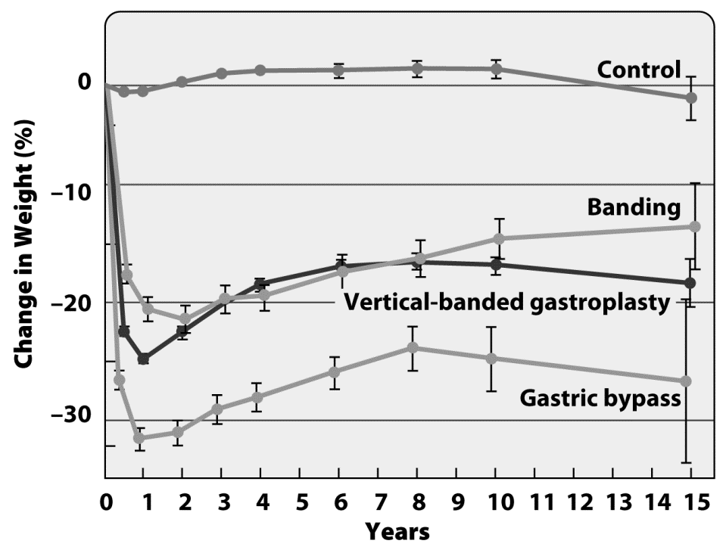
90. Which group had the greatest immediate weight loss?
Answer: gastric bypass
DQ: What are the risks and benefits of bariatric surgery?
Type: Use It
Difficulty: Hard
Important Words/Concepts: gastric bypass surgery, gastric banding surgery

91. Which group had the greatest long-term weight loss?

Answer: gastric bypass

DQ: What are the risks and benefits of bariatric surgery?
Type: Use It
Difficulty: Hard
Important Words/Concepts: gastric bypass surgery, gastric banding surgery

92. Which group regained the most weight 15 years after the surgery?

Answer: gastric banding

DQ: What are the risks and benefits of bariatric surgery?
Type: Use It
Difficulty: Hard
Important Words/Concepts: gastric bypass surgery, gastric banding surgery

93. The graph illustrates some of the study’s results. From it, you can conclude that _________.
  - patients who underwent gastric banding had lost about 15 pounds at the end of 15 years, while those who underwent gastric bypass lost about 25 pounds
  - patients who underwent gastric banding had lost about 15% of their body weight at the end of 15 years, while those who underwent gastric bypass lost about 25%
  - patients in the experimental group lost weight initially but gained it all back by the end of the study
  - patients in the control group lost no weight by the end of the study
  - None of the above.
Answer: B
DQ: What are the risks and benefits of bariatric surgery?
Type: Use It
Difficulty: Hard
Important Words/Concepts: gastric bypass surgery, gastric banding surgery

94. The graph illustrates some of the study’s results. The vertical lines at each data point are called error bars. As a general rule, when the error bars from two different data points or lines overlap, we can conclude that the two points or lines are not significantly different from one another. Or, put another way, we can conclude that any difference we see is due to chance, not to any real difference in the data. Given this information, which of the following best describes the results?
  - Results from the control group, the two banding groups, and the gastric bypass groups are all significantly different from one another. Gastric bypass patients lost more weight than did vertical-banded gastroplasty patients, who lost more than did banding patients, who lost more than did the control patients.
  - The gastric bypass patients lost significantly more weight than did the banding patients and the control patients.
  - The banding patients lost significantly less weight than did the vertical-banded gastroplasty patients.
  - The gastric bypass patients didn’t lose significantly more weight than did the banding patients, but those both the bypass and the banding patients lost significantly more weight than did the control patients.
  - None of these accurately describes the results shown in the graph.
Answer: B
DQ: What are the risks and benefits of bariatric surgery?
Type: Use It
Difficulty: Hard
Important Words/Concepts: gastric bypass surgery, gastric banding surgery

The following two questions (95-96) require interpretation of the graph below:

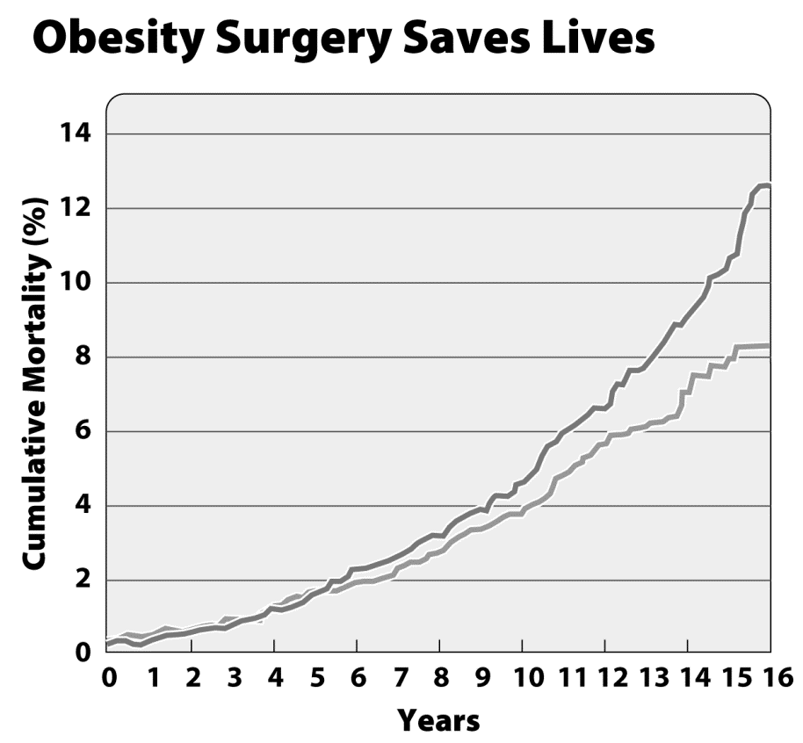

95. In 2007, Swedish researchers published results from a study in which they followed about 2000 obese patients who had undergone weight-loss surgery—either gastric bypass or surgical banding—over 15 years and compared them with about 2000 similarly obese people who didn’t have surgery but who were counseled in diet and exercise. One goal of the study was to determine whether bariatric surgery saved lives as a consequence of reducing patients’ weights. This graph illustrates some of their results. Based on these results and what you know about the pros and cons of bariatric surgery, would you recommend it as a good treatment for morbid obesity? Explain.

Answer: Data from this study support the hypothesis that morbidly obese patients who undergo bariatric surgery have lower cumulative mortality than do patients who undergo weight-loss counseling alone—this is the benefit. Cons include diet restrictions, complications of surgery, etc. Students should address both and make a recommendation. The best students will point out that these results come from a single study; results from additional studies would be helpful.

DQ: What are the risks and benefits of bariatric surgery?
Type: Use It
Difficulty: Hard
Important Words/Concepts: gastric bypass surgery, gastric banding surgery

96. Interpret the data in the graph.

Answer: The data show that people who undergo weight-loss surgery have a decreased death rate when compared with people who did not undergo weight-loss surgery.

DQ: What are the risks and benefits of bariatric surgery?
Type: Use It
Difficulty: Hard
Important Words/Concepts: gastric bypass surgery, gastric banding surgery

Use the information below to answer questions 97 and 98.
In 2007, Swedish researchers published results from a study in which they followed about 2000 obese patients who had undergone weight-loss surgery—either gastric bypass or surgical banding—over 15 years and compared them with about 2000 similarly obese people who didn’t have surgery but who were counseled in diet and exercise. One goal of the study was to determine whether bariatric surgery led to greater weight loss than diet and exercise counseling.

97. In this study, the control group was made up of _________.
  - the patients who had gastric bypass surgery
  - the patients who had gastric banding surgery
  - the patients who had no surgery but were counseled in diet and exercise
  - patients who received neither surgery nor counseling in diet and exercise
  - This study had no control.
Answer: C
DQ: What are the risks and benefits of bariatric surgery?
Type: Use It
Difficulty: Hard
Important Words/Concepts: gastric bypass surgery, gastric banding surgery

98. In this study, the independent variable was ________, and the dependent variable was _________.
  - the intervention (surgery versus diet/exercise counseling); weight loss
  - the type of surgery; weight loss
  - diet and exercise counseling; weight loss
  - weight loss; the intervention
  - weight loss; the type of surgery
Answer: A
DQ: What are the risks and benefits of bariatric surgery?
Type: Use It
Difficulty: Hard
Important Words/Concepts: gastric bypass surgery, gastric banding surgery

99. Weight-loss surgery has _________.
- no benefit besides weight loss
- very few side effects
- a higher death rate associated with it than remaining obese
- a lower death rate than obesity
- only been recommended for people with a BMI greater than 20
Answer: D
DQ: What are the risks and benefits of bariatric surgery?
Type: Know It
Difficulty: Hard
Important Words/Concepts: gastric bypass surgery, gastric banding surgery

100. What is bariatric surgery?

Answer: Bariatric surgery is surgery that changes the anatomy of the digestive system, limiting the amount of food a person can eat and digest before feeling full
DQ: What are the risks and benefits of bariatric surgery?

Type: Know It
Difficulty: Easy
Important Words/Concepts: gastric bypass surgery, gastric banding surgery, stomach, small intestine

101. Does food bypass the stomach after gastric bypass surgery? Explain.

Answer: Food does not completely bypass the stomach. Stomach digestion is an integral part of the digestive system, especially for acquisition of amino acids. Gastric bypass surgery does, however, bypass most of the stomach, as well as a large part of the small intestine. This greatly reduces the absorption of food particles and, therefore, the calorie content of food.

DQ: What are the risks and benefits of bariatric surgery?
Type: Use It
Difficulty: Hard
Important Words/Concepts: gastric bypass surgery, gastric banding surgery, stomach, small intestine, absorption

102. In gastric bypass surgery, the stomach is sealed, except for a _________.
- small pouch at the bottom
- a small pouch in the center
- a small pouch at the top
- pouch about half the stomach’s normal size at the top
- pouch about half the stomach’s normal size at the bottom
Answer: C
DQ: What are the risks and benefits of bariatric surgery?
Type: Know It
Difficulty: Medium
Important Words/Concepts: gastric bypass surgery, gastric banding surgery, stomach

103. The “bypass” in gastric bypass surgery refers to _________.
- the decrease in size of the stomach
- the position of the stomach pouch
- a change in the position of the connection between the stomach and the small intestine
- a change in the position of the connection between the stomach and the esophagus
- A and D
Answer: C
DQ: What are the risks and benefits of bariatric surgery?
Type: Use It
Difficulty: Medium
Important Words/Concepts: gastric bypass surgery, gastric banding surgery, stomach, small intestine

104. Which part of gastric bypass surgery do you think creates the worst side effects: reducing the volume of the stomach or bypassing the upper part of the small intestine? Describe the side effects of each, and their causes, and provide a rationale for your answer.

Answer: Stomach reduction causes severe, acute nausea, discomfort, and possibly diarrhea in response to overeating or eating too many carbohydrates. Bypassing the upper part of the small intestine reduces the amount of nutrients that are absorbed from food, making it easy to become malnourished. The effectiveness of bile salts in emulsifying fats is reduced since food enters the small intestine downstream of the gallbladder. This can lead to fatty stools. Opinions and justifications will vary.

DQ: What are the risks and benefits of bariatric surgery?
Type: Use It
Difficulty: Hard
Important Words/Concepts: gastric bypass surgery, gastric banding surgery, stomach, small intestine

105. Gastric dumping is a condition that causes nausea and diarrhea and is associated with eating too much/too many __________ after gastric bypass surgery.
- fat
- carbohydrates
- protein
- food
- fat and protein
Answer: B
DQ: What are the risks and benefits of bariatric surgery?
Type: Know It
Difficulty: Medium
Important Words/Concepts: gastric bypass surgery, gastric banding surgery

106. If you were morbidly obese, would you try gastric bypass, gastric banding, or diet modification without surgery? Explain your answer.

Answer: Answers will vary; look for examples of risks and benefits.

DQ: What are the risks and benefits of bariatric surgery?
Type: Use It
Difficulty: Hard
Important Words/Concepts: gastric bypass surgery, gastric banding surgery

