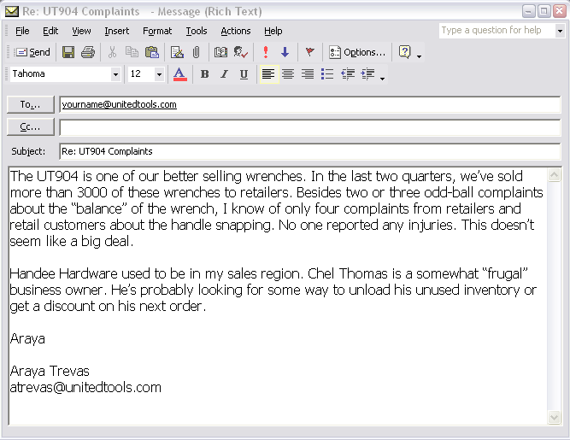

Re: UT904 Complaints

The UT904 is one of our better-selling wrenches. In the last two quarters, we’ve sold more than 3,000 of these wrenches to retailers. Besides two or three oddball complaints about the “balance” of the wrench, I know of only four complaints from retailers and retail customers about the handle snapping. No one reported any injuries. This doesn’t seem like a big deal.

Handee Hardware used to be in my sales region. Chel Thomas is a somewhat “frugal” business owner. He’s probably looking for some way to unload his unused inventory or get a discount on his next order.

Araya

Araya Trevas
atrevas@unitedtools.com

