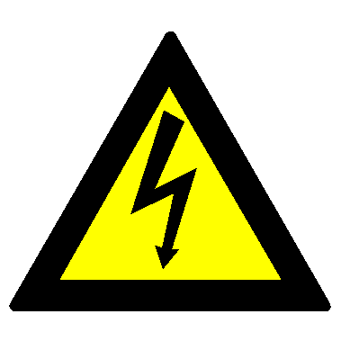
Warning of Electrical Shock Hazard #1

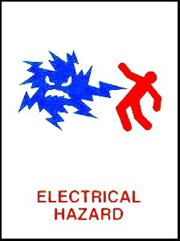
Warning of Electrical Shock Hazard #2

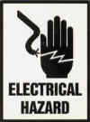
Warning of Electrical Shock Hazard #3

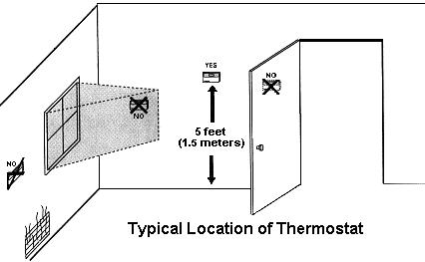
Thermostat Placement

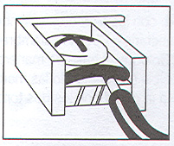
Wire-Terminal Attachment Showing Black Spacer
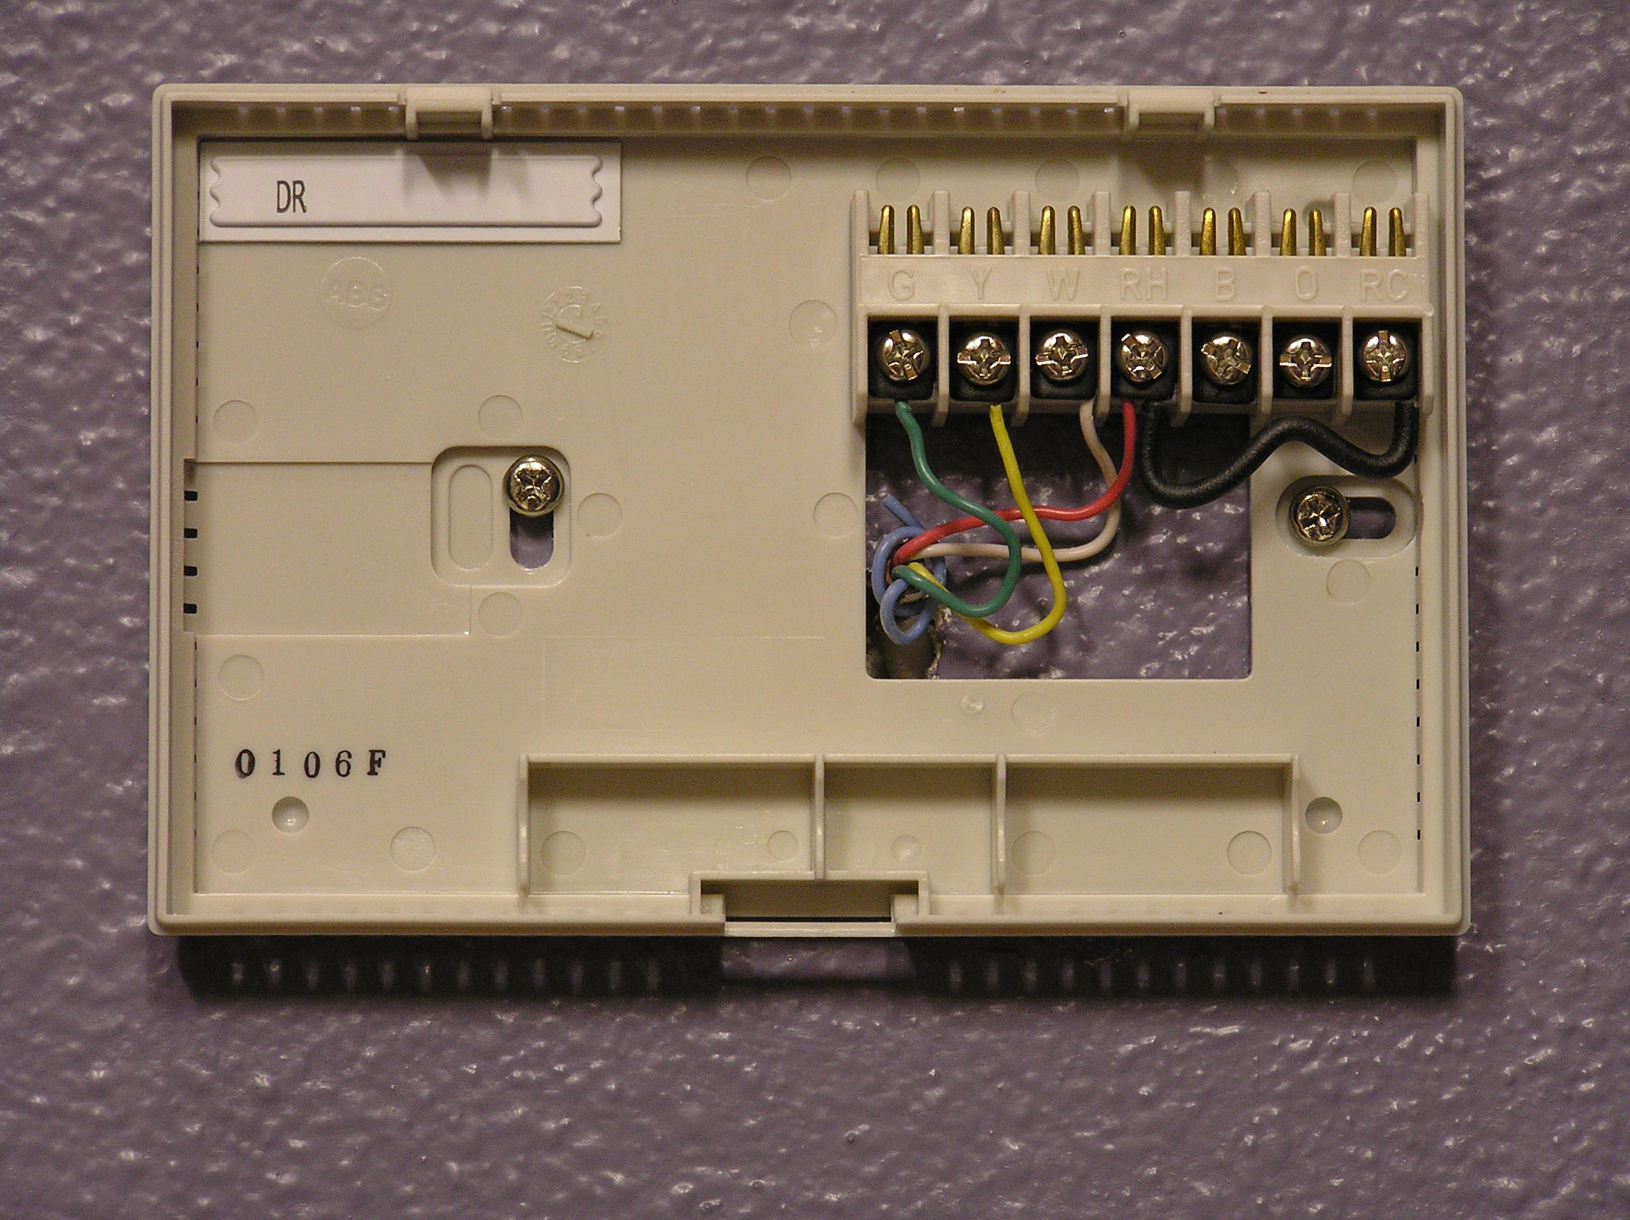
Base of EC37 Showing Wires Attached to Terminals

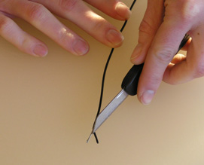
Stripping Insulation from Wire #1

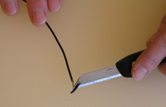
Stripping Insulation from Wire #2

